

Practical No. : 5
Aim –
Use JavaScript function types, scope, closures; apply try-catch; build a palindrome checker.
Software/Tools Required –
VSCode, Chrome, HTML5, CSS3, Javascript (ES6)
Experiment Program Code –
Index.html
<!DOCTYPE html>
<html lang="en">

<head>
<meta charset="UTF-8">
<meta name="viewport" content="width=device-width, initial-scale=1.0">
<title>Shopping Cart Calculator</title>

<style>
body {
font-family: Arial;
background: #f2f2f2;
margin: 0;
padding: 0;
}

.container {
width: 800px;
margin: 30px auto;
background: white;
padding: 20px;
border-radius: 10px;
box-shadow: 0 0 10px gray;
}

h2 {
text-align: center;
}

input {
padding: 8px;
width: 150px;
margin: 5px;
}

button {
padding: 10px;
cursor: pointer;
}

table {
width: 100%;
border-collapse: collapse;
margin-top: 20px;
}

table, th, td {
border: 1px solid black;
}

th {
background: #007bff;
color: white;
}

th, td {
padding: 10px;
text-align: center;
}

.result {
margin-top: 20px;
font-size: 18px;
}

footer {
margin-top: 30px;
padding: 15px;
text-align: center;
background: #007bff;
color: white;
border-radius: 5px;
font-size: 15px;
}
</style>
</head>

<body>

<div class="container">

<h2>Shopping Cart Calculator</h2>

<input type="text" id="name" placeholder="Product Name">

<input type="number" id="price" placeholder="Price">

<input type="number" id="qty" placeholder="Quantity">

<button onclick="addProduct()">Add Product</button>

<table id="cartTable">
<tr>
<th>ID</th>
<th>Product</th>
<th>Price</th>
<th>Quantity</th>
<th>Total</th>
</tr>
</table>

<div class="result" id="result">

<h3>Item Summary</h3>
<ul id="summary"></ul>

<h3>Expensive Products (Price > 1000)</h3>
<ul id="expensive"></ul>

</div>

</div>

<script>

let cart = [];

function addProduct() {

let name = document.getElementById("name").value;

let price = parseFloat(
document.getElementById("price").value
);

let qty = parseInt(
document.getElementById("qty").value
);

if (name == "" || isNaN(price) || isNaN(qty)) {

alert("Please enter all fields");

return;
}

let product = {

id: cart.length + 1,

name: name,

price: price,

quantity: qty
};

cart.push(product);

displayCart();

document.getElementById("name").value = "";

document.getElementById("price").value = "";

document.getElementById("qty").value = "";
}

function displayCart() {

let table = document.getElementById("cartTable");

table.innerHTML = `
<tr>
<th>ID</th>
<th>Product</th>
<th>Price</th>
<th>Quantity</th>
<th>Total</th>
</tr>
`;

cart.forEach(function(item) {

table.innerHTML += `
<tr>
<td>${item.id}</td>
<td>${item.name}</td>
<td>${item.price}</td>
<td>${item.quantity}</td>
<td>${item.price * item.quantity}</td>
</tr>
`;

});

let total = cart.reduce(function(sum, item) {

return sum + (item.price * item.quantity);

}, 0);

let discount = 0;

if (total >= 50000) {

discount = total * 0.20;

}

else if (total >= 20000) {

discount = total * 0.10;

}

else if (total >= 5000) {

discount = total * 0.05;

}

let finalAmount = total - discount;

document.getElementById("result").innerHTML = `

<b>Total Amount :</b> ${total}<br>

<b>Discount :</b> ${discount.toFixed(2)}<br>

<b>Final Amount :</b> ${finalAmount.toFixed(2)}

<h3>Item Summary</h3>

<ul id="summary"></ul>

<h3>Expensive Products (Price > 1000)</h3>

<ul id="expensive"></ul>

`;

let summary = document.getElementById("summary");

summary.innerHTML = "";

cart.map(function(item) {

summary.innerHTML +=
`<li>${item.name} : ${item.price * item.quantity}</li>`;

});

let expensive = document.getElementById("expensive");

expensive.innerHTML = "";

let exp = cart.filter(function(item) {

return item.price > 1000;

});

exp.forEach(function(item) {

expensive.innerHTML +=
`<li>${item.name}</li>`;

});

}

</script>

</body>

</html>

Output –
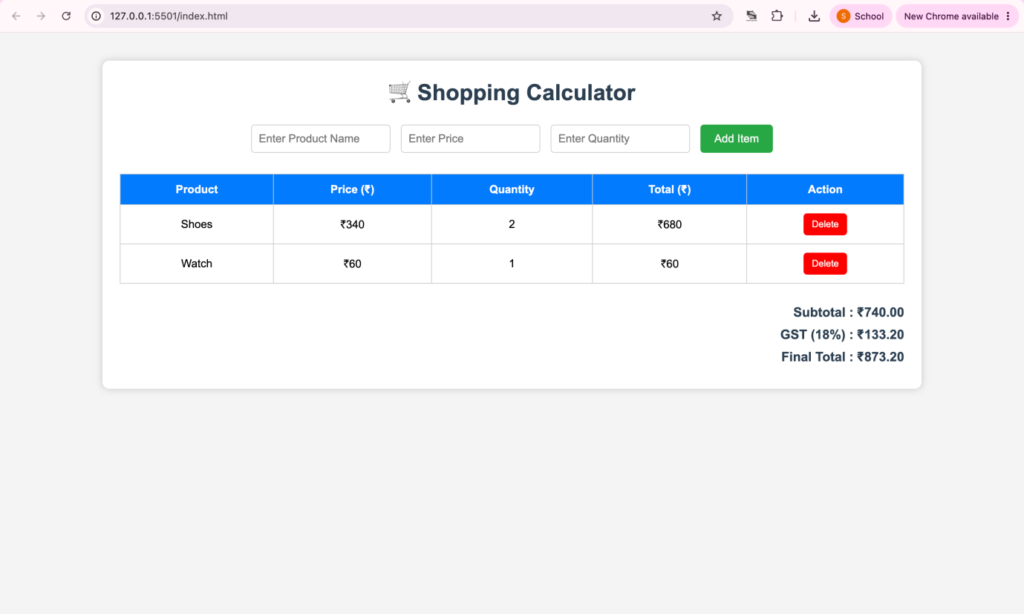
Case Study Title –
To study the functioning of Arrays and Loops in Java Script
a) Create and manipulate arrays: push, pop, shift, unshifit, splice, slice. b) Use array methods: mapO, filter(), reduce(), forEach (.
Case Study: -
Create an array of numbers and find the maximum and minimum value.
Case Study Program Code –
index.html
<!DOCTYPE html>
<html lang="en">

<head>
<meta charset="UTF-8">
<meta name="viewport" content="width=device-width, initial-scale=1.0">
<title>Movie Ticket Booking System</title>
<link rel="stylesheet" href="style.css">
</head>

<body>

<div class="container">

<h1>🎬 Movie Ticket Booking System</h1>

<div class="main">

<!-- Left Card -->

<div class="card">

<h2>Book Ticket</h2>

<label>Select Movie</label>

<select id="movieSelect" onchange="showPrice()">

<option value="0">Avengers</option>
<option value="1">Superman</option>
<option value="2">Jurassic World</option>
<option value="3">F1</option>
<option value="4">Pushpa 2</option>

</select>

<label>Ticket Price</label>

<input type="text" id="price" readonly>

<button onclick="addBooking()">
➕ Add Booking
</button>

</div>

<!-- Right Card -->

<div class="card">

<h2>Your Bookings</h2>

<div id="bookingList">

No bookings yet.

</div>

<button onclick="removeBooking()">
❌ Remove Last Booking
</button>

</div>

</div>

<!-- Bottom Section -->

<div class="output">

<h2>Booking Analysis</h2>

<div class="btnRow">

<button onclick="premiumMovies()">
⭐ Premium Movies
</button>

<button onclick="highestLowest()">
📈 Highest & Lowest
</button>

</div>

<div id="result">

Select an operation.

</div>

</div>

</div>
<footer>

Designed by <strong>Rudrakshi Bhandekar</strong> | PRN: <strong>24070521012</strong><br>
</footer>
<script src="script.js"></script>

</body>

</html>

style.css
*{
margin:0;
padding:0;
box-sizing:border-box;
font-family:Segoe UI, Tahoma, Geneva, Verdana, sans-serif;
}

body{
background:linear-gradient(135deg,#eef2ff,#fdfdfd);
min-height:100vh;
padding:40px;
}

.container{
width:90%;
max-width:1100px;
margin:auto;
}

h1{
text-align:center;
color:#b71c1c;
font-size:38px;
margin-bottom:8px;
}

p{
text-align:center;
color:#555;
font-size:17px;
margin-bottom:30px;
}

.main{
display:flex;
gap:25px;
margin-bottom:25px;
}

.card{
flex:1;
background:white;
padding:25px;
border-radius:18px;
box-shadow:0 8px 20px rgba(0,0,0,0.15);
border-top:6px solid #d32f2f;
}

.card h2{
text-align:center;
color:#b71c1c;
margin-bottom:20px;
}

label{
display:block;
margin-bottom:8px;
margin-top:15px;
font-weight:bold;
color:#333;
}

select,
input{
width:100%;
padding:12px;
border:2px solid #ddd;
border-radius:10px;
font-size:16px;
margin-bottom:15px;
background:#fafafa;
}

select:focus,
input:focus{
border-color:#d32f2f;
outline:none;
}

button{
width:100%;
padding:12px;
margin-top:12px;
border:none;
border-radius:10px;
background:#d32f2f;
color:white;
font-size:16px;
font-weight:bold;
cursor:pointer;
transition:0.3s;
}

button:hover{
background:#8e0000;
transform:translateY(-2px);
}

#bookingList{
background:#fff8f8;
border:2px dashed #d32f2f;
border-radius:10px;
padding:15px;
min-height:170px;
white-space:pre-line;
line-height:1.8;
margin-bottom:15px;
}

.output{
background:white;
padding:25px;
border-radius:18px;
box-shadow:0 8px 20px rgba(0,0,0,0.15);
}

.output h2{
text-align:center;
color:#b71c1c;
margin-bottom:20px;
}

.btnRow{
display:flex;
gap:20px;
margin-bottom:20px;
}

.btnRow button{
flex:1;
}

#result{
background:#fffdf7;
border:2px solid #f2d2d2;
border-radius:10px;
min-height:180px;
padding:15px;
white-space:pre-line;
line-height:1.8;
font-size:16px;
}

@media(max-width:768px){

.main{
flex-direction:column;
}

.btnRow{
flex-direction:column;
}

}
footer{
width:100%;
text-align:center;
color:white;
font-size:20px;
padding:15px 0;
background:rgba(0,0,0,.35);
backdrop-filter:blur(6px);
}

footer strong{
color:#112b30;
}

script.js
let movies = [
"Avengers",
"Superman",
"Jurassic World",
"F1",
"Pushpa 2"
];

let prices = [
180,
250,
320,
450,
200
];

let bookings = [];
window.onload = showPrice;

function showPrice(){

let index = document.getElementById("movieSelect").value;

document.getElementById("price").value = "₹ " + prices[index];

}

function addBooking(){

let index = document.getElementById("movieSelect").value;
let booking = {

movie : movies[index],
price : prices[index]

};

bookings.push(booking);
displayBookings();
document.getElementById("result").innerHTML =
"✅ Booking Added Successfully!";
}

function displayBookings(){

let text = "";
if(bookings.length==0){
text = "No bookings yet.";
}

else{
bookings.forEach(function(item,i){
text += (i+1)+". 🎬 "+item.movie+
" - ₹"+item.price+"\n";
});

}
document.getElementById("bookingList").innerText = text;

}

function removeBooking(){

if(bookings.length==0){

alert("No booking available!");

return;

}
bookings.pop();
displayBookings();
document.getElementById("result").innerHTML =
"❌ Last Booking Removed.";

}

function premiumMovies(){

let premium = bookings.filter(function(item){
return item.price > 300;
});

let text = "⭐ Premium Bookings\n\n";

if(premium.length==0){
text += "No Premium Movie Booked.";
}

else{
premium.forEach(function(item){

text += "🎬 "+item.movie+
" - ₹"+item.price+"\n";

});

}
document.getElementById("result").innerText = text;
}

function highestLowest(){
if(bookings.length==0){

document.getElementById("result").innerText =
"No Bookings Available.";
return;

}

let bookedPrices = [];
bookings.forEach(function(item){
bookedPrices.push(item.price);

});

let highest = Math.max(...bookedPrices);
let lowest = Math.min(...bookedPrices);
let highMovie = "";
let lowMovie = "";
bookings.forEach(function(item){
if(item.price == highest){
highMovie = item.movie;
}

if(item.price == lowest){
lowMovie = item.movie;
}

});

document.getElementById("result").innerText =
"📈 Highest Booked Movie\n\n"+
highMovie+" - ₹"+highest+

"\n\n📉 Lowest Booked Movie\n\n"+
lowMovie+" - ₹"+lowest;

}

Output – 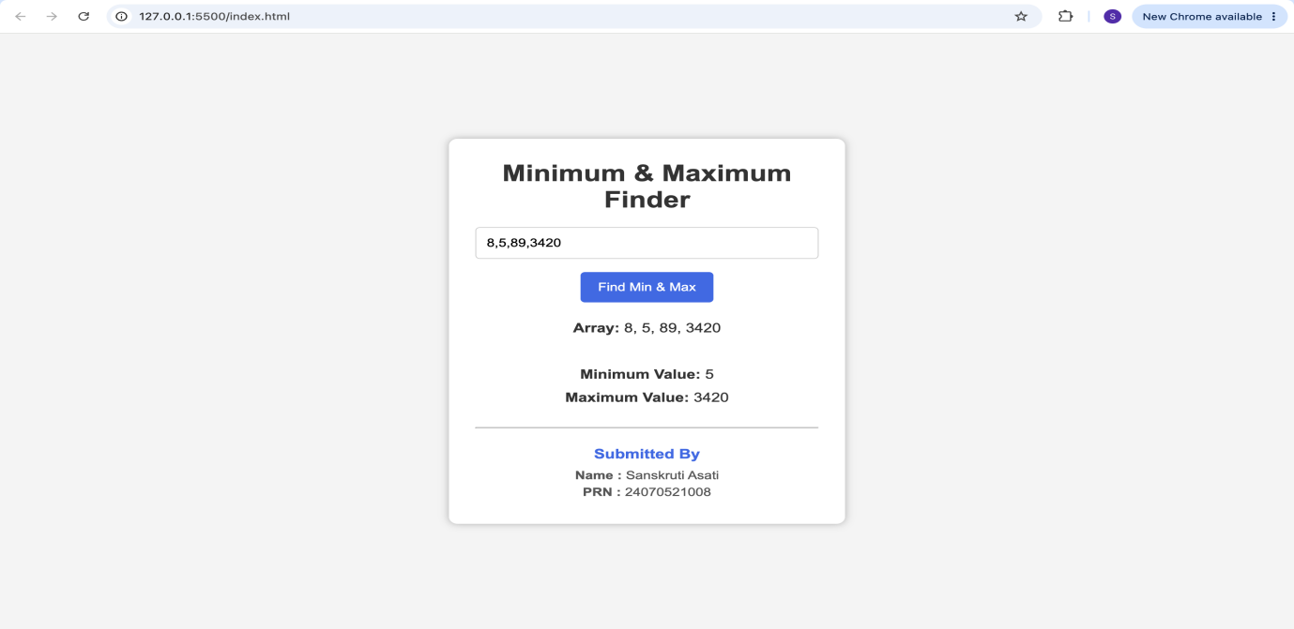
Conclusion –
The experiment was successfully performed to study JavaScript arrays, array manipulation methods, array iteration methods, loops and object handling. A Shopping Cart Calculator was developed to store product objects, calculate the total amount and apply discount logic. A Maximum and Minimum Finder was also implemented using array traversal to determine the largest and smallest values from an array of numbers.

